1. normal cyclic prefix = 4,7 µs =====>a max. delay of 1.4km can be compensated.
2. if TDD, the GP of special subframe decide the possible cell size in DL.  
   e.g. config 8 has the smallest GP= 2192 Ts in round trip. and 1 Ts mean (3 10e8)/(15k\*2048)=9.76m  
   so it 2192Ts====>max cell size 22km/2=11km
3. if TDD: cp of UpPTS:  
   There are: 2192/4384 Ts ==>2.2km /4.4 km delay
4. PRACH

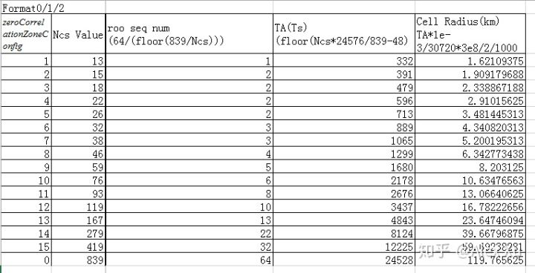

类似任何guard time = 下行最大延迟 + 最大上行TA 值, 由于上下行对称, 所以可以认为TA = 1/2 guard time. so 332Ts===>1.6km

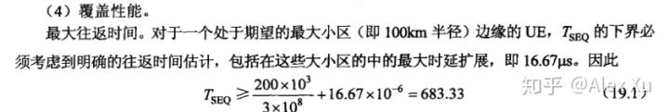

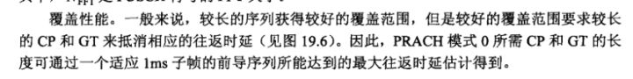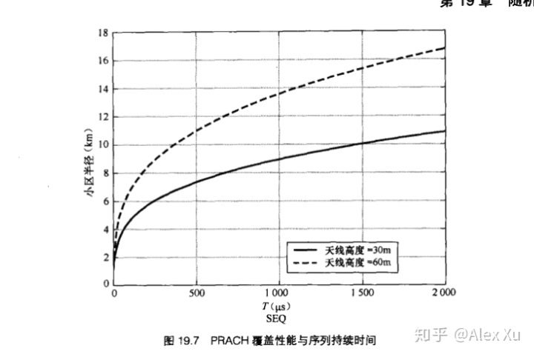



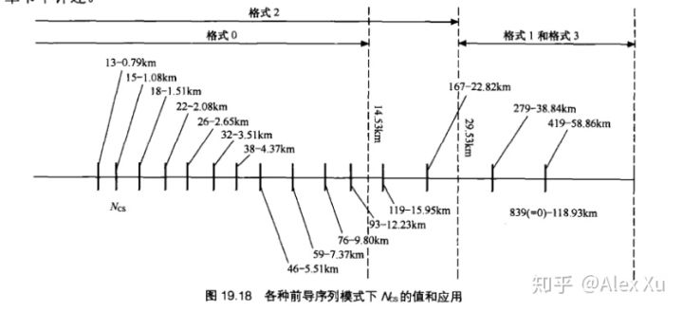

4. TA command adjustment:

the unit is 16 Ts, the command use 11bits.